Community Read Activity Guide
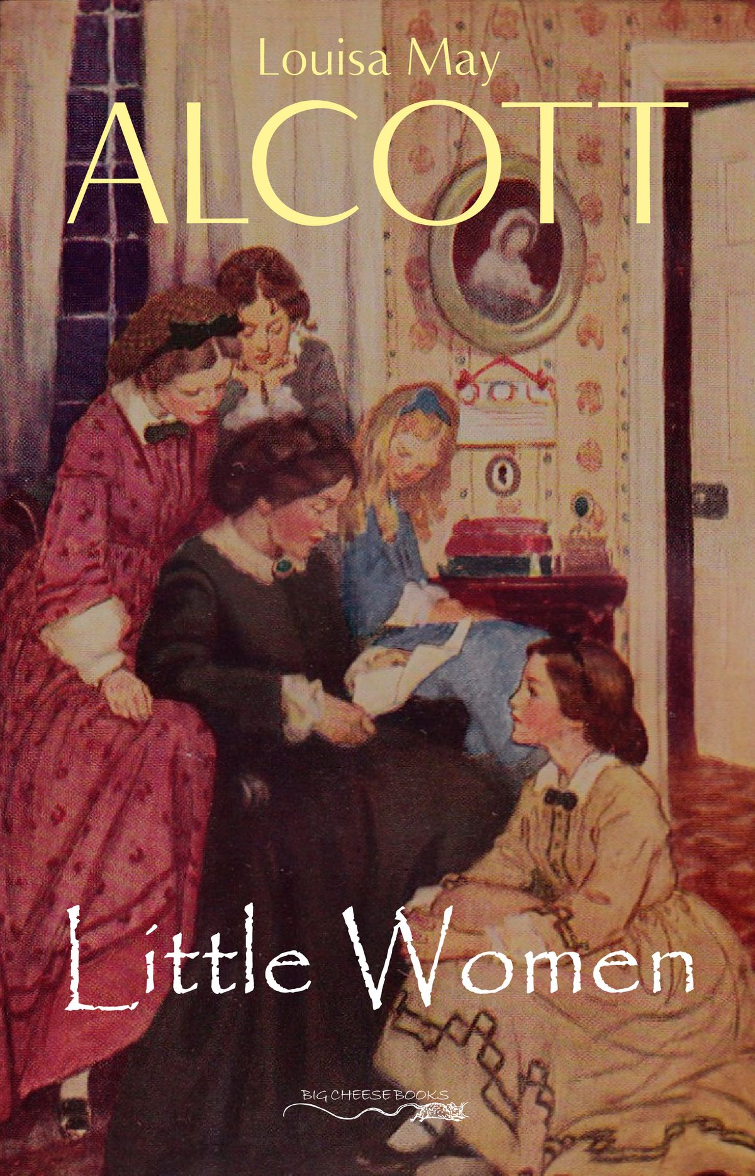December 15-18, 2020
Thank you for participating in the 2020 Christmas Community Read in a Bag. This guide is meant to provide you with everything you need to host your own discussion and celebration at home.
This year’s theme for the Bucket List Book Club is Books About Books. When I was considering what books I wanted to include this year, I knew there had to be a place for one of my old favourites. Little Women is the semi autobiographical work by Louisa May Alcott. It tells the story of Jo March and her three sisters as they grow up and become women, and mirrors Alcott’s own childhood and journey to becoming a published author. It also highlights the importance of relying on one’s family in both good times and bad.
We hope you enjoy this year’s Community Read. Please post pictures on social media and tag the Three Hills Library or send pictures to athmprogramming@marigold.ab.ca. We would love to celebrate with you.

About the Author

Louisa May Alcott (November 29, 1832-March 6, 1888) was born in Germantown, Pennsylvania to Transcendentalist Amos Bronson Alcott and social worker Abby May. She was the second of four daughters with sisters Anna, Elizabeth, and Abigail.
In 1834, the family moved to Boston where her father founded an experimental school and joined the Transcendental Club with Ralph Waldo Emerson and Henry David Thoreau. After Fruitlands, a utopian community begun by her father, failed, Alcott lost faith in his ability to provide for their family and took on that responsibility herself, working various teaching and domestic jobs before becoming a published writer.
Her first stories were published under the pen name A.M. Barnard and were filled with violence and revenge, an appeal to what was popular at the time in an attempt to make money.
Alcott volunteered as a nurse in the American Civil War but she contracted typhoid and was sent home. She never completely recovered.
She continued writing, publishing her letters and short stories. In 1968-69, she wrote Little Women, based on her life with her four sisters. It was an immediate success.
Unlike her character, Jo, Alcott never married. She spent her last years caring for her ailing parents and her niece and died shortly after her father in 1888.

Discussion Questions

- Who is your favourite character in Little Women and why?
- Have you read this book before? What things did you remember? What things did you forget?
- Have you seen any of the movie adaptations of this book? How do you think they compare?
- Which of the sisters do you identify with most and why?
- Jo is the central character of the novel. How do you think this book would be different if the novel was told from someone else’s point of view?
- When Jo takes Beth to the seashore for one last visit, Beth compares the four sisters to birds. If you compared yourself to a bird, what kind would you be?
- Were you disappointed that Jo did not marry Laurie? Or did you think Professor Bhaer was the better choice for her? Why?
- What do you think this book says about the nature of sibling relationships? What scenes illustrate best the bond between the March sisters?
- This book is loosely based on Louisa May Alcott’s life and relationship with her own sisters. What do you think Jo’s character reveals about the author?
- Alcott was a student of transcendentalism. What do you know about this philosophy? How does it affect her writing?

Hot Apple Cider

Servings: 6
Ingredients
- 1 1.65L carton apple juice (fresh pressed, not from concentrate is best)
- 2 chai spice tea bags or caffeine free equivalent.
- 1 navel orange or 2 mandarin oranges
Directions
- Pour apple juice into pot.
- Add tea bags.
- Slice navel orange or peel and section mandarin oranges.
- Add to apple juice.
- Heat over medium high heat until steaming.
- Turn down to low heat and simmer for twenty minutes
- Serve hot.

Recipe by Leah Cote

Old Fashioned Gingerbread

Servings: 9
Ingredients
- 1/2 cup butter, cubed
- 1/4 cup shortening, cubed
- 1 cup boiling water
- 2 large eggs, room temperature
- 1-1/2 cups molasses
- 2 cups all-purpose flour
- 1 tablespoon ground ginger
- 2 teaspoons baking powder
- 1 teaspoon ground cinnamon
- 1/2 teaspoon salt
- 1/4 teaspoon baking soda
- Confectioners' sugar, optional
Directions
- Preheat oven to 350°.
- Grease a 9-in. square baking pan; set aside.
- In a large bowl, mix butter, shortening and boiling water until smooth; cool slightly.
- Beat in eggs and molasses until well blended.
- In another bowl, whisk flour, ginger, baking powder, cinnamon, salt and baking soda; gradually beat into molasses mixture.
- Transfer to prepared pan.
- Bake until a toothpick inserted in centre comes out clean, 35-40 minutes. Cool completely on wire rack.
- If desired, sprinkle with confectioners' sugar before serving.

Recipe from tasteofhome.com.

Activities

Story Circle
- Gather in a circle.
- Choose a person to go first.
- The first person begins with “Once Upon a Time...”
- Everyone goes around the circle, adding sentences until the story is complete.

Create your own Pickwick Portfolio
- Write a family newspaper.
- Collect stories, poems, and artwork from each member of the family.
- Read and discuss each person’s contribution during your family’s Community Read Celebration.

Put on a Play
- Create costumes from clothing and items around your home.
- Re-enact your favourite scenes from the book as dramatically as possible.

Merry Christmas
and
Happy New Year
from the
Three Hills Library!

